**Experiment 1**

**Aim:** To study and plot the characteristics of a junction diode in forward and reverse biased condition and calculate its dynamic resistance in each condition.

**Tools Used:** Virtual Labs.

**Theory:**

**Structure of P-N junction diode:** The diode is a device formed from a junction of n-type and p-type semiconductor material. The lead connected to the p-type material is called the anode and the lead connected to the n-type material is the cathode. In general, the cathode of a diode is marked by a solid line on the diode.

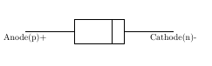

Fig 1: Structure of p-n Junction Diode

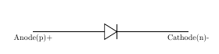

Fig 2: Symbol of p-n Junction Diode

**Function of a P-N junction diode in Forward Bias**: The positive terminal of battery is connected to the P side(anode) and the negative terminal of battery is connected to the N side(cathode) of a diode, the holes in the p-type region and the electrons in the n-type region are pushed toward the junction and start to neutralize the depletion zone, reducing its width. The positive potential applied to the p-type material repels the holes, while the negative potential applied to the n-type material repels the electrons. The change in potential between the p side and the n side decreases or switches sign. With increasing forward-bias voltage, the depletion zone eventually becomes thin enough that the zone's electric field cannot counteract charge carrier motion across the p–n junction, which as a consequence reduces electrical resistance. The electrons that cross the p–n junction into the p-type material (or holes that cross into the n-type material) will diffuse into the nearby neutral region. The amount of minority diffusion in the near-neutral zones determines the amount of current that may flow through the diode.

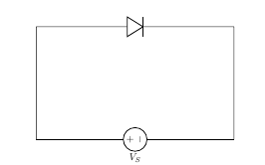

Fig 3: Representation of p-n Junction Diode in Forward Biasing Condition

**Function of a P-N junction diode in Reverse Bias:** The positive terminal of battery is connected to the N side(cathode) and the negative terminal of battery is connected to the P side(anode) of a diode. Therefore, very little current will flow until the diode breaks down. The positive terminal of battery is connected to the N side(cathode) and the negative terminal of battery is connected to the P side(anode) of a diode, the 'holes' in the p-type material are pulled away from the junction, leaving behind charged ions and causing the width of the depletion region to increase. Likewise, because the n-type region is connected to the positive terminal, the electrons will also be pulled away from the junction, with similar effect. This increases the voltage barrier causing a high resistance to the flow of charge carriers, thus allowing minimal electric current to cross the p–n junction. The increase in resistance of the p–n junction results in the junction behaving as an insulator.

The strength of the depletion zone electric field increases as the reverse-bias voltage increases. Once the electric field intensity increases beyond a critical level, the p–n junction depletion zone breaks down and current begins to flow, usually by either the Zener or the avalanche breakdown processes. Both of these breakdown processes are non-destructive and are reversible, as long as the amount of current flowing does not reach levels that cause the semiconductor material to overheat and cause thermal damage.

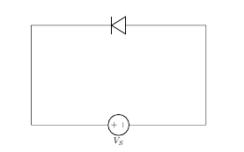

Fig 3: Representation of p-n Junction Diode in Reverse Biasing Condition

**Forward and Reverse Biased Characteristics of a Silicon diode:**

1. Forward Biasing: In forward biasing, the positive terminal of battery is connected to the P side and the negative terminal of battery is connected to the N side of the diode. Diode will conduct in forward biasing because the forward biasing will decrease the depletion region width and overcome the barrier potential. In order to conduct, the forward biasing voltage should be greater than the barrier potential. During forward biasing the diode acts like a closed switch with a potential drop of nearly 0.6 V across it for a silicon diode. The forward and reverse bias characteristics of a silicon diode. From the graph, you may notice that the diode starts conducting when the forward bias voltage exceeds around 0.6 volts (for Si diode). This voltage is called cut-in voltage.
2. Reverse Biasing: In reverse biasing, the positive terminal of battery is connected to the N side and the negative terminal of battery is connected to the P side of a diode. In reverse biasing, the diode does not conduct electricity, since reverse biasing leads to an increase in the depletion region width; hence current carrier charges find it more difficult to overcome the barrier potential. The diode will act like an open switch and there is no current flow.

**Forward and Reverse Biased Characteristics of a Germanium diode:**

1. Forward Biasing: In forward biasing, the positive terminal of battery is connected to the P side and the negative terminal of battery is connected to the N side of the diode. Diode will conduct in forward biasing because the forward biasing will decrease the depletion region width and overcome the barrier potential. In order to conduct, the forward biasing voltage should be greater than the barrier potential. During forward biasing the diode acts like a closed switch with a potential drop of nearly 0.3 V across it for a germanium diode. The forward and reverse bias characteristics of a germanium diode. From the graph, you may notice that the diode starts conducting when the forward bias voltage exceeds around 0.3 volts (for Ge diode). This voltage is called cut-in voltage.
2. Reverse Biasing: In reverse biasing, the positive terminal of battery is connected to the N side and the negative terminal of battery is connected to the P side of a diode. In reverse biasing, the diode does not conduct electricity, since reverse biasing leads to an increase in the depletion region width; hence current carrier charges find it more difficult to overcome the barrier potential. The diode will act like an open switch and there is no current flow.

Diode Equation: In the forward-biased and reversed-biased regions, the current (If), and the voltage (Vf), of a semiconductor diode are related by the diode equation:

$$I_{f}=I_{s}×\left(e^{V_{f}/ɳ×V_{t}}-1\right)$$

where,

Is is reverse saturation current or leakage current,

If is current through the diode(forward current),

Vf is potential difference across the diode terminals(forward voltage)

VT is thermal voltage, given by

$$V_{t }=\left(K×T\right)/q$$

and

K is Boltzmann’s constant = 1.38x10−23 J /°Kelvin,

q is the electronic charge = 1.6x10−19 joules/volt (Coulombs),

T is the absolute temperature in °Kelvin (°K = 273 + temperature in °C),

At room temperature (25 °C), the thermal voltage is about 25.7 mV,

ɳ is an empirical constant between 0.5 and 2

The empirical constant, ɳ, is a number that can vary according to the voltage and current levels. It depends on electron drift, diffusion, and carrier recombination in the depletion region. Among the quantities affecting the value of ɳ are the diode manufacture, levels of doping and purity of materials.

If ɳ=1, the value of (K×T)/q is 26 mV at 25°C.

When ɳ=2, the value of (KxT)/q becomes 52 mV. For germanium diodes, ɳ is usually considered to be close to 1. For silicon diodes, ɳ is in the range of 1.3 to 1.6.

**Diode Resistance:** Resistance is the opposition offered to the flow of current through the device. Hence, diode resistance can be defined as the effective opposition offered by the diode to the flow of current through it. Ideally speaking, a diode is expected to offer zero resistance when forward biased and infinite resistance when reverse biased. However, no device can ever be ideal. Thus, practically speaking, every diode is seen to offer a small resistance when forward biased, and a considerable resistance when reverse biased. One can characterise the given diode regarding its forward and reverse resistances.

1. Forward Resistance: Even after forward biasing, the diode will not conduct until it reaches a minimum threshold voltage level. After the applied voltage exceeds this threshold level, the diode starts to conduct. We refer the resistance, offered by the diode under this condition as the forward resistance of the diode. That is, the forward resistance is nothing but the resistance offered by the diode when the diode is working in its forward biased condition. Forward resistance is classified into two types viz., static or dynamic depending on whether the current flowing through the device is D.C. (Direct Current) or A.C. (Alternating Current), respectively.
   * + 1. Static or DC Resistance: It is the resistance offered by the diode to the flow of DC through it when we apply a DC voltage to it. Mathematically the static resistance is expressed as the ratio of DC voltage applied across the diode terminals to the DC flowing through it i.e.

Rdc=Vdc/Idc

* + - 1. Dynamic or AC Resistance: It is the resistance offered by the diode to the flow of AC through it when we connect it in a circuit which has an AC voltage source as an active circuit element. Mathematically the dynamic resistance is given as the ratio of change in voltage applied across the diode to the resulting change in the current flowing through it. This is shown by the slope-indicating red solid lines in Figure 1 and is expressed as:

Rac=Vdc/Idc (Point to point)

1. Reverse Resistance: When we connect the diode in reverse biased condition, there will be a small current flowing through it which is called the reverse leakage current. We can attribute the cause behind this to the fact that when the diode functions in its reverse mode, it will not be completely free of charge carriers. That is, even in this state, one can experience the flow of minority carriers through the device. Due to this current flow, the diode exhibits reverse resistance characteristic which is shown by the purple dotted line in Figure 1. The mathematical expression for the same is similar to that for the forward resistance and is given by

Rr=Vr/Ir

Where, Vr and Ir are the reverse voltage and the reverse current respectively.

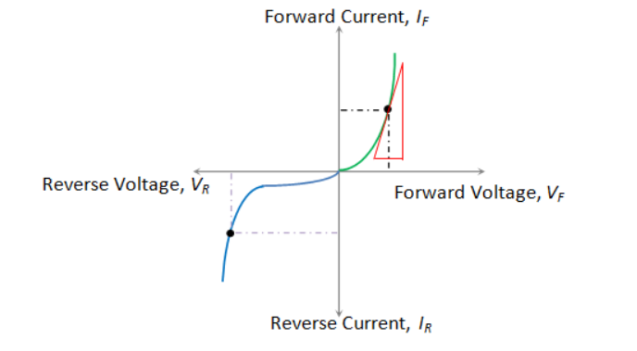

Fig 5: Diode Resistance Shown as a Part of a Resistance.

**Circuit Diagram:**

1. Silicon Diode:
2. Forward Biasing:

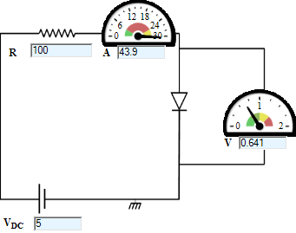

1. Reverse Biasing:

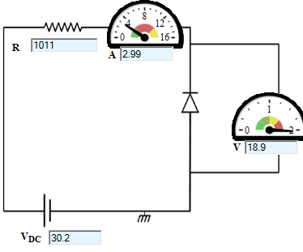

1. Germanium Diode:
2. Forward Biasing:

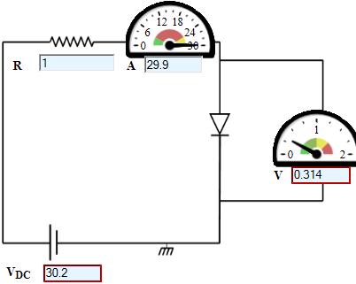

1. Reverse Biasing:

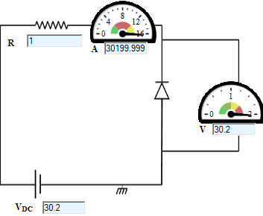

**Wiring Diagram:**

1. Forward Biasing:

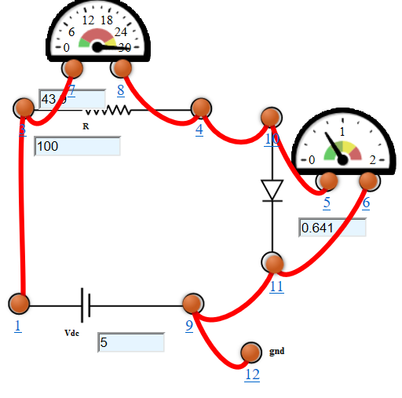

1. Reverse Biasing:

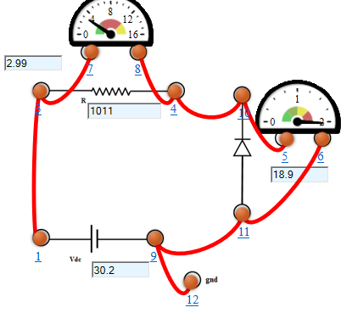

**Graph:**

1. Silicon Diode:
2. Forward Biasing:

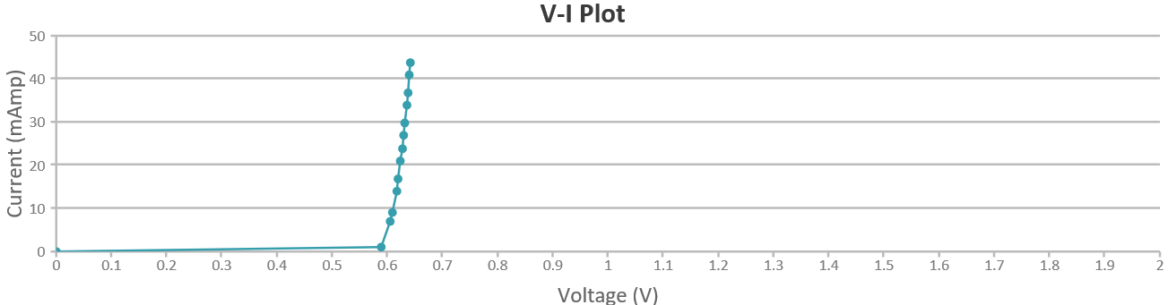

1. Reverse Biasing:

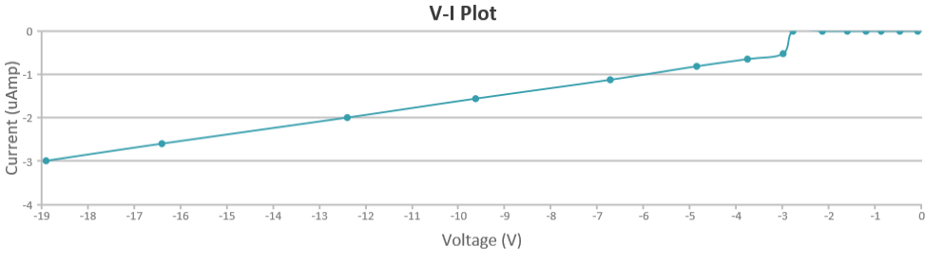

1. Germanium Diode:
2. Forward Biasing:

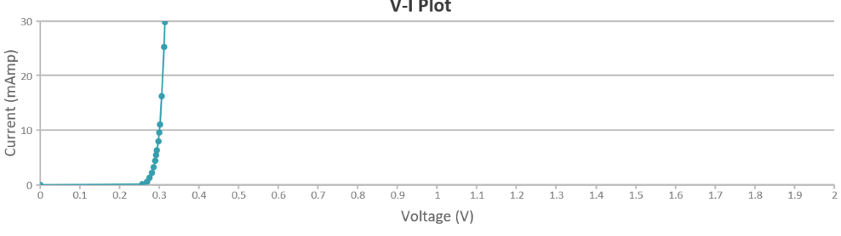

1. Reverse Biasing:

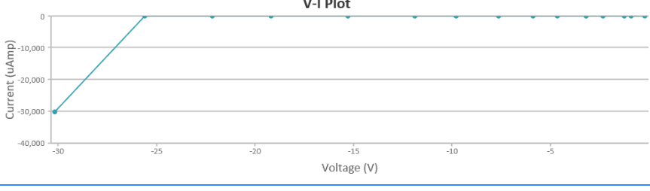

**Observations:**

1. Silicon Diode:
2. Forward Biasing:

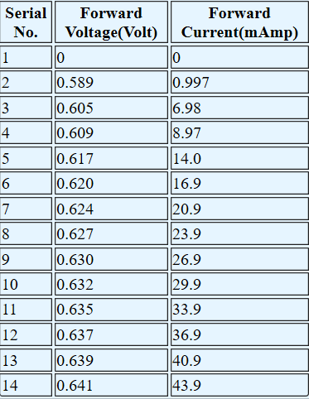

1. Reverse Biasing:

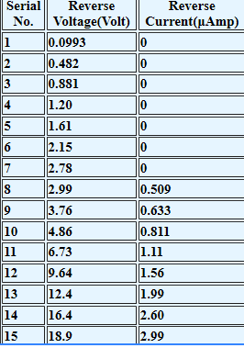

1. Germanium Diode:
2. Forward Biasing:

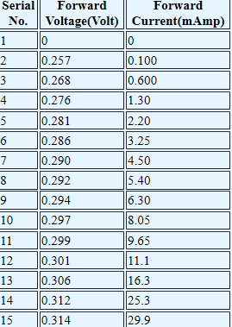

1. Reverse Biasing:

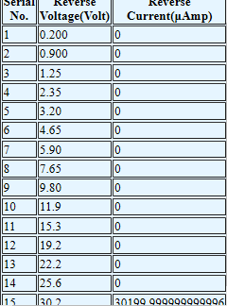

**Calculations:** Dynamic Resistance for Silicon Diode

1. Forward Biasing:

From the graph,

V1= 2.77 Volts

V2= 3.07 Volts

I1= 0.570 Amp

I2= 0.573 Amp

Dynamic Resistance, Rac = Vdc/Idc = (V2-V1)/(I2-I1)

= (3.07-2.77)/(0.573-0.570)

= 0.3/0.003=100Ω

1. Reverse Biasing:

From the graph,

V1= 6.48 Volts

V2= 8.36 Volts

I1= 1.07 µAmp

I2= 1.41 µAmp

Dynamic Resistance, Rac = Vdc/Idc = (V2-V1)/(I2-I1)

= (8.36-6.48)/(1.41-1.07)

= (1.88 x 106)/0.34=5.529 x 106Ω

**Result:** From the graph we get:

1. Silicon Diode:

Forward Cut-in Voltage = 0.589 Volts $≈$ 0.6 Volts

Knee Voltage = 0.589 Volts $≈$ 0.6 Volts

Reverse Saturation Current= -3µAmpere

1. Germanium Diode:

Forward Cut-in Voltage $=$ 0.257 Volts $≈$ 0.3 Volts

Knee Voltage = 0.257 Volts $≈$ 0.3 Volts

Reverse Saturation Current= -30,000 µAmpere

**Conclusion:** The V-I characteristics of forward biasing and reverse biasing current has been obtained and studied successfully.